Slant Height
# Source: AI Source: Provided by: [Data Path: Persons Table -> ID Column: 1, Name_En Column: Motasem Essam] -> From: [ChatGPT] on [7/20/2026]
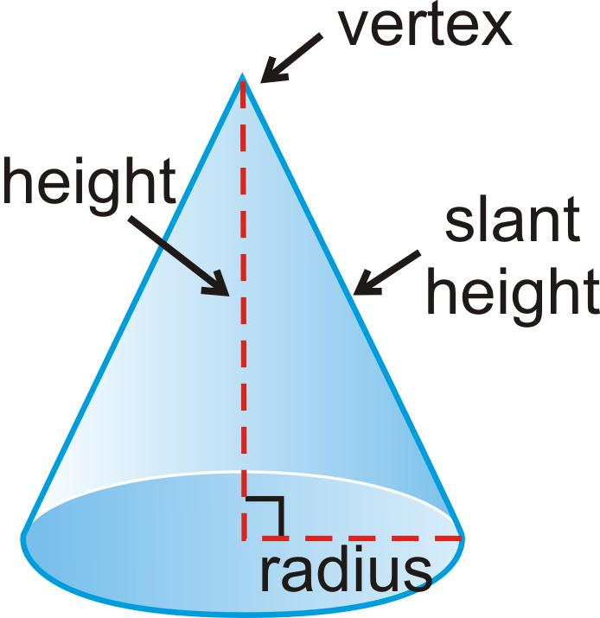
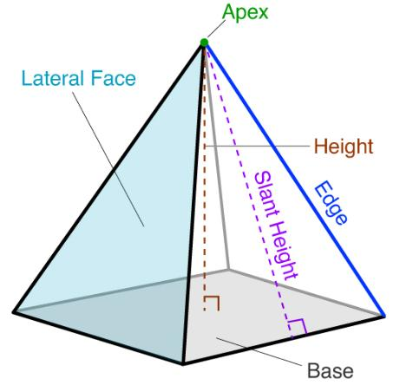
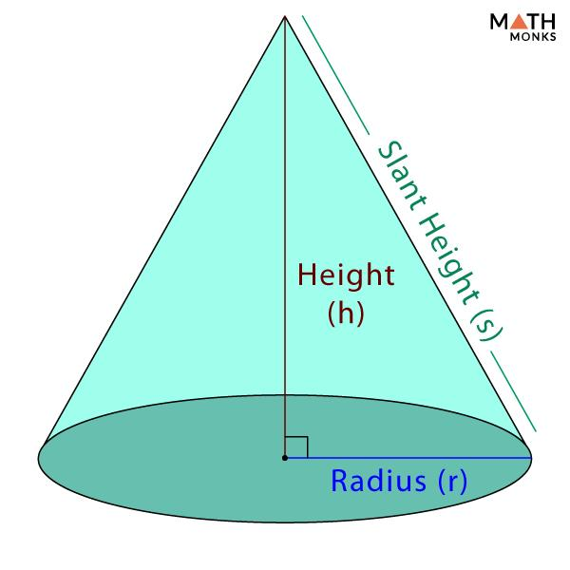
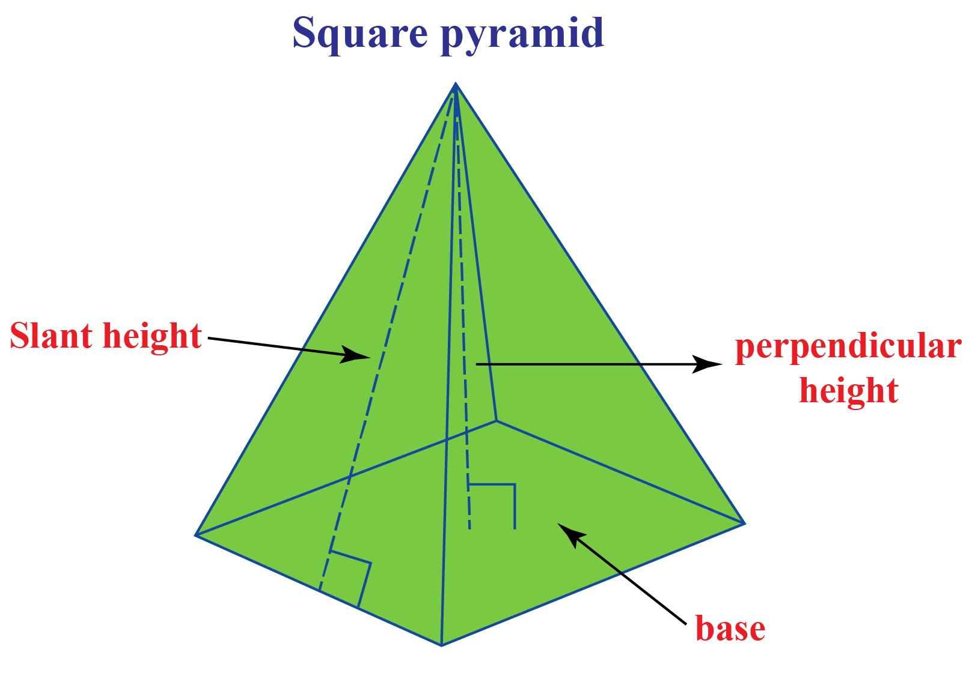
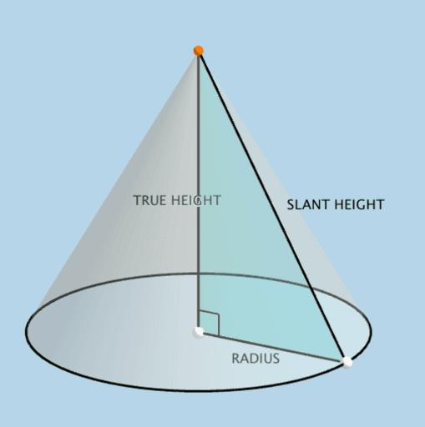

Definition
# Source: AI Source: Provided by: [Data Path: Persons Table -> ID Column: 1, Name_En Column: Motasem Essam] -> From: [ChatGPT] on [7/20/2026]
Slant Height is the length of a straight line measured along the sloping surface of a three-dimensional geometric object, typically a right circular cone or a regular pyramid.
It is different from the perpendicular height, which is measured at a right angle to the base.
For a right circular cone:
$$\boxed{l=\sqrt{r^{2}+h^{2}}}$$
where:
- $l$= slant height
- $r$= base radius
- $h$= perpendicular height

Purpose
# Source: AI Source: Provided by: [Data Path: Persons Table -> ID Column: 1, Name_En Column: Motasem Essam] -> From: [ChatGPT] on [7/20/2026]
Slant height is used to:
- Calculate the lateral surface area of cones.
- Calculate the total surface area of cones.
- Calculate the lateral surface area of regular pyramids.
- Establish geometric relationships between height, radius, and sloping edges.
- Solve right-triangle problems in three-dimensional geometry.
- Determine dimensions when developing curved surfaces into flat figures.

Fundamental Elements
# Source: AI Source: Provided by: [Data Path: Persons Table -> ID Column: 1, Name_En Column: Motasem Essam] -> From: [ChatGPT] on [7/20/2026]
For a right circular cone, the important measurements are:
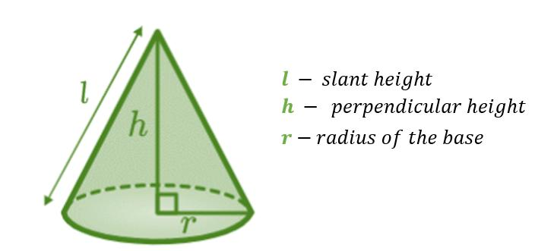
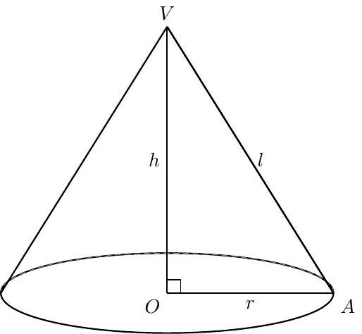
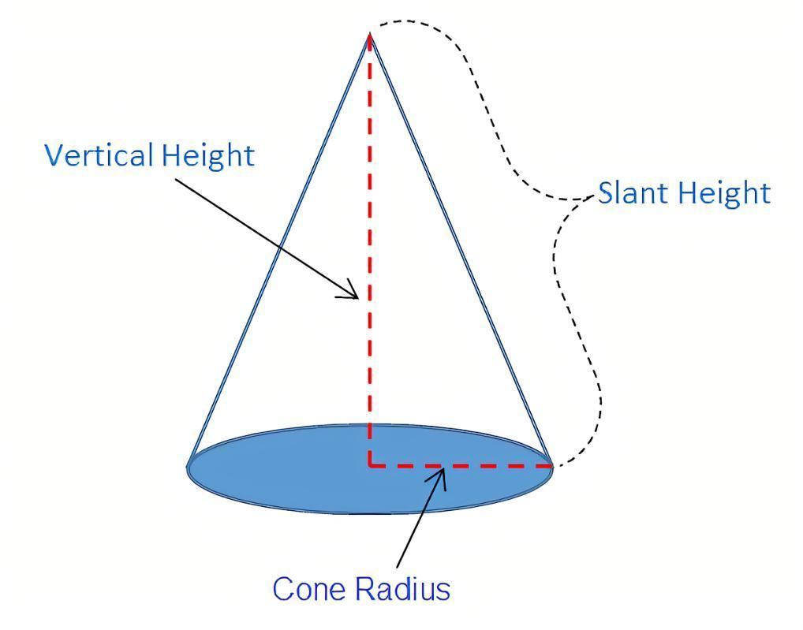

1. Perpendicular Height $h$
# Source: AI Source: Provided by: [Data Path: Persons Table -> ID Column: 1, Name_En Column: Motasem Essam] -> From: [ChatGPT] on [7/20/2026]
The perpendicular height is the shortest distance from the vertex to the plane of the base.
It meets the base at a right angle:
$$\boxed{h⊥\text{base}}$$

2. Radius $r$
# Source: AI Source: Provided by: [Data Path: Persons Table -> ID Column: 1, Name_En Column: Motasem Essam] -> From: [ChatGPT] on [7/20/2026]
The radius extends from the center of the circular base to its boundary.

3. Slant Height $l$
# Source: AI Source: Provided by: [Data Path: Persons Table -> ID Column: 1, Name_En Column: Motasem Essam] -> From: [ChatGPT] on [7/20/2026]
The slant height extends from the vertex to a point on the circumference of the circular base along the cone's lateral surface.
For a right circular cone:
$$\boxed{l>h}$$
and:
$$\boxed{l>r}$$
for positive $r,h$.

Slant Height of a Right Circular Cone
# Source: AI Source: Provided by: [Data Path: Persons Table -> ID Column: 1, Name_En Column: Motasem Essam] -> From: [ChatGPT] on [7/20/2026]
The radius, perpendicular height, and slant height form a right triangle.
Therefore, by the Pythagorean theorem:
$$l^{2}=r^{2}+h^{2}$$
Thus:
$$\boxed{l=\sqrt{r^{2}+h^{2}}}$$
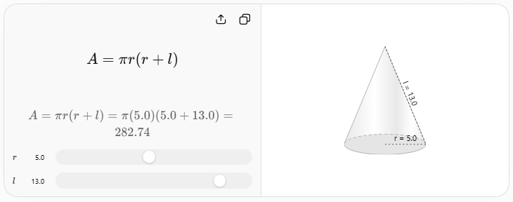

Example 1 — Finding Slant Height
# Source: AI Source: Provided by: [Data Path: Persons Table -> ID Column: 1, Name_En Column: Motasem Essam] -> From: [ChatGPT] on [7/20/2026]
Suppose a right circular cone has:
$$r=5\text{ cm}$$
and:
$$h=12\text{ cm}$$
Then:
$$l=\sqrt{r^{2}+h^{2}} \\ l=\sqrt{5^{2}+{12}^{2}} \\ l=\sqrt{25+144} \\ l=\sqrt{169}$$
Therefore:
$$\boxed{l=13\text{ cm}}$$
This is the familiar $5-12-13$right triangle.

Finding Height from Slant Height
# Source: AI Source: Provided by: [Data Path: Persons Table -> ID Column: 1, Name_En Column: Motasem Essam] -> From: [ChatGPT] on [7/20/2026]
If $l$and $r$are known:
$$l^{2}=r^{2}+h^{2}$$
Therefore:
$$\boxed{h=\sqrt{l^{2}-r^{2}}}$$
Example
If:
$$l=13\text{ cm}$$
and:
$$r=5\text{ cm}$$
then:
$$h=\sqrt{{13}^{2}-5^{2}} \\ h=\sqrt{169-25} \\ h=\sqrt{144} \\ \boxed{h=12\text{ cm}}$$

Finding Radius from Slant Height
# Source: AI Source: Provided by: [Data Path: Persons Table -> ID Column: 1, Name_En Column: Motasem Essam] -> From: [ChatGPT] on [7/20/2026]
Similarly:
$$l^{2}=r^{2}+h^{2}$$
so:
$$\boxed{r=\sqrt{l^{2}-h^{2}}}$$
Example
If:
$$l=10\text{ cm}$$
and:
$$h=8\text{ cm}$$
then:
$$r=\sqrt{{10}^{2}-8^{2}} \\ r=\sqrt{100-64} \\ \boxed{r=6\text{ cm}}$$

Slant Height and Cone Surface Area
# Source: AI Source: Provided by: [Data Path: Persons Table -> ID Column: 1, Name_En Column: Motasem Essam] -> From: [ChatGPT] on [7/20/2026]
The slant height is particularly important for calculating the lateral surface area of a right circular cone:
$$\boxed{A_{L}=πrl}$$
The total surface area is:
$$\boxed{A_{T}=πrl+πr^{2}}$$
or:
$$\boxed{A_{T}=πr\left(r+l\right)}$$
The slant height appears because the curved surface of the cone unfolds into a sector of a circle whose radius is $l$.

Slant Height and Development of a Cone
# Source: AI Source: Provided by: [Data Path: Persons Table -> ID Column: 1, Name_En Column: Motasem Essam] -> From: [ChatGPT] on [7/20/2026]
When the lateral surface of a right circular cone is cut and unfolded, it forms a circular sector.
The sector has:
- Radius $=l$
- Arc length $=2πr$
Therefore:
$$\boxed{\text{Sector radius}=l}$$
This explains why $l$is used in the cone's lateral surface-area formula.

Slant Height of a Regular Pyramid
# Source: AI Source: Provided by: [Data Path: Persons Table -> ID Column: 1, Name_En Column: Motasem Essam] -> From: [ChatGPT] on [7/20/2026]
The concept of slant height also applies to a regular pyramid.
For a regular pyramid, the slant height is the distance from the apex to the midpoint of a base side, measured along a lateral face.
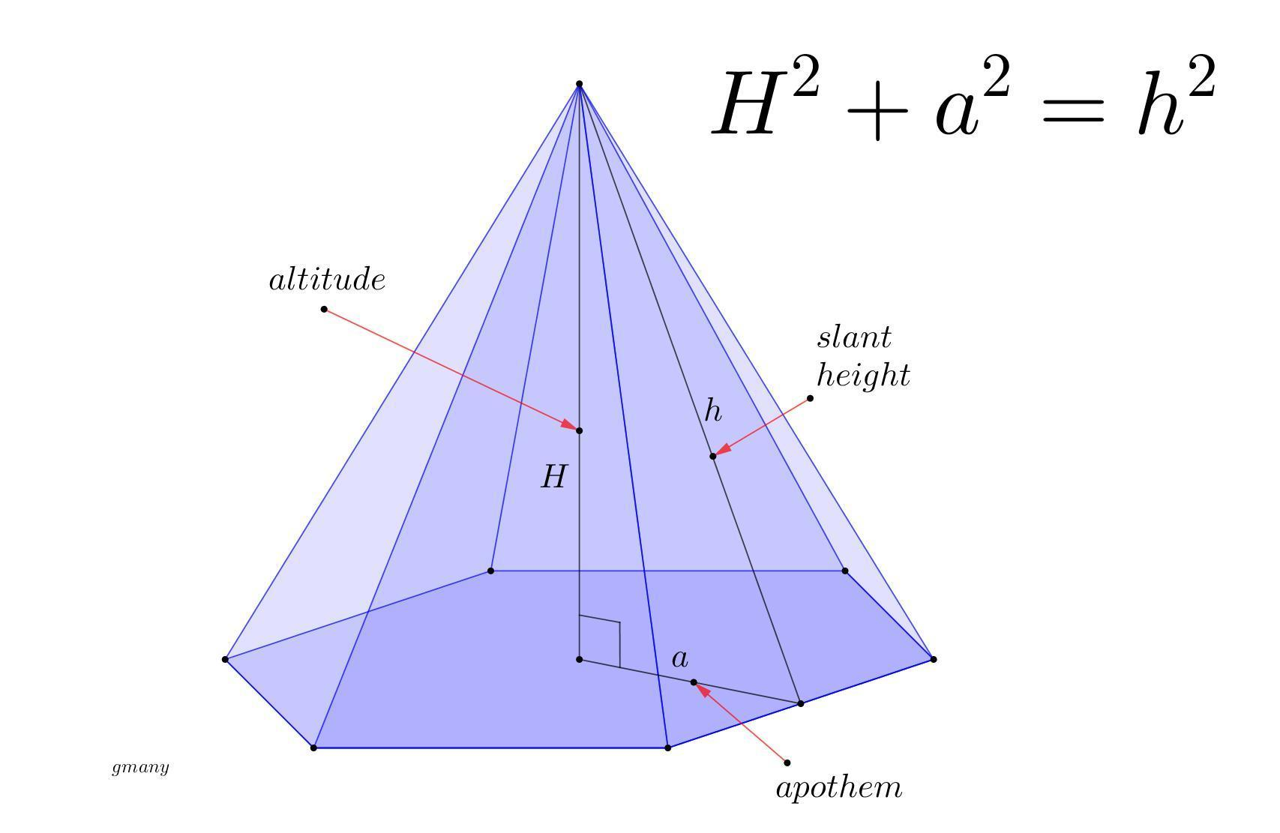
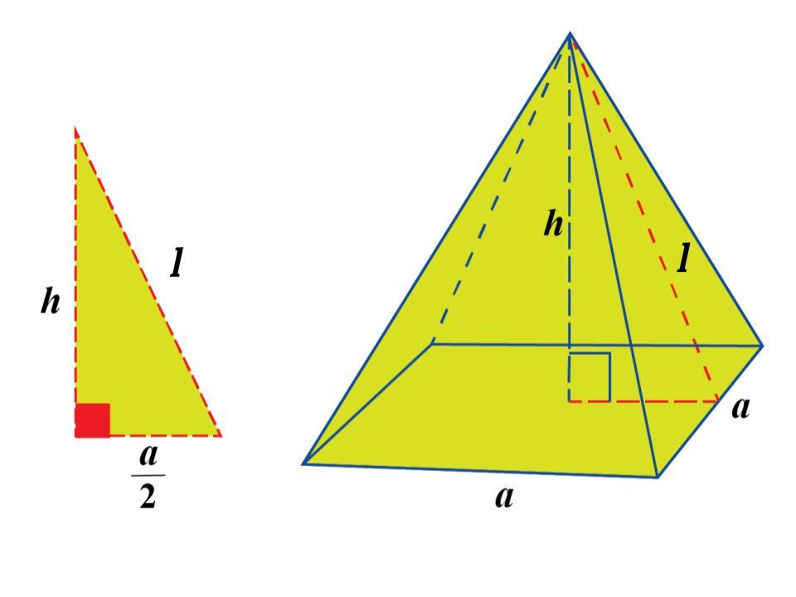
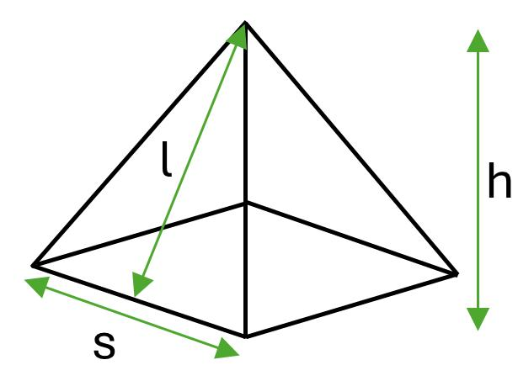
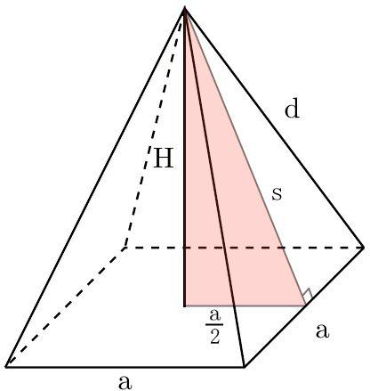
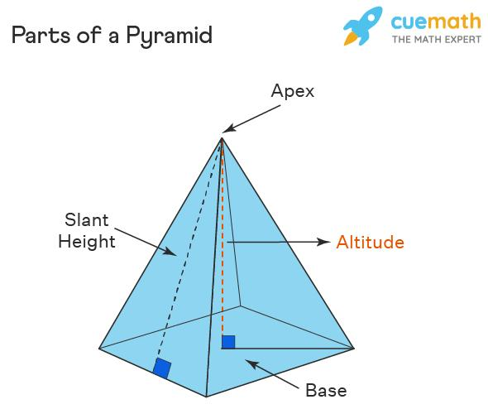
For a regular pyramid:
$$\boxed{l=\sqrt{h^{2}+a^{2}}}$$
where:
- $l$= slant height
- $h$= perpendicular height
- $a$= apothem of the base
The right triangle is formed by:
- perpendicular height $h$,
- base apothem $a$,
- slant height $l$.

Cone vs Pyramid Slant Height
# Source: AI Source: Provided by: [Data Path: Persons Table -> ID Column: 1, Name_En Column: Motasem Essam] -> From: [ChatGPT] on [7/20/2026]
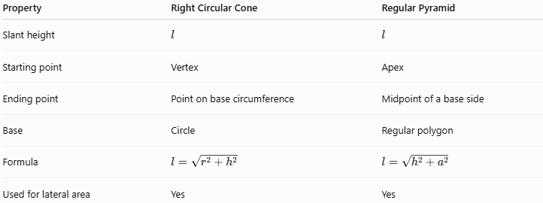
Property | Right Circular Cone | Regular Pyramid
Slant height | $$l$$ | $$l$$
Starting point | Vertex | Apex
Ending point | Point on base circumference | Midpoint of a base side
Base | Circle | Regular polygon
Formula | $$l=\sqrt{r^{2}+h^{2}}$$ | $$l=\sqrt{h^{2}+a^{2}}$$
Used for lateral area | Yes | Yes

Important Distinction: Slant Height vs Slant Edge
# Source: AI Source: Provided by: [Data Path: Persons Table -> ID Column: 1, Name_En Column: Motasem Essam] -> From: [ChatGPT] on [7/20/2026]
These terms should not be confused.
Slant Height
For a regular pyramid, the slant height goes from the apex to the midpoint of a base side.
Slant Edge
A slant edge goes from the apex to a base vertex.
For a square pyramid, for example:
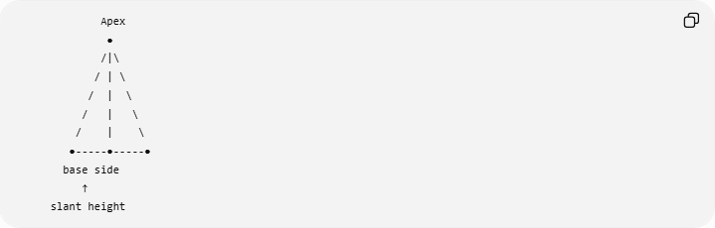
Apex
●
/|\
/ | \
/ | \
/ | \
/ | \
●-----●-----●
base side
↑
slant height
The slant edge and slant height generally have different lengths.

Slant Height in an Oblique Cone
# Source: AI Source: Provided by: [Data Path: Persons Table -> ID Column: 1, Name_En Column: Motasem Essam] -> From: [ChatGPT] on [7/20/2026]
An important qualification is necessary.
The simple formula:
$$\boxed{l=\sqrt{r^{2}+h^{2}}}$$
applies to a right circular cone.
For an oblique circular cone, the vertex is not directly above the center of the base. Consequently, the generators from the vertex to different points on the circular base generally have different lengths.
Therefore, an oblique cone does not generally have one universal slant height satisfying:
$$l^{2}=r^{2}+h^{2}$$
This distinction is important for your previous topic Oblique Circular Conical Surface.

Main Properties
# Source: AI Source: Provided by: [Data Path: Persons Table -> ID Column: 1, Name_En Column: Motasem Essam] -> From: [ChatGPT] on [7/20/2026]
- Slant height is measured along a sloping surface or lateral face.
- It is commonly denoted by:
$$\boxed{l}$$
- For a right circular cone:
$$\boxed{l=\sqrt{r^{2}+h^{2}}}$$
- It is always greater than the perpendicular height for a non-degenerate right circular cone:
$$\boxed{l>h}$$
- It is used in the lateral surface area of a cone:
$$\boxed{A_{L}=πrl}$$
- It is used in the total surface area:
$$\boxed{A_{T}=πr\left(r+l\right)}$$
- For a regular pyramid:
$$\boxed{l=\sqrt{h^{2}+a^{2}}}$$
- The meaning of slant height depends on the solid being considered.
- The standard cone formula should not be applied automatically to oblique cones.

Relationship with Related Concepts
# Source: AI Source: Provided by: [Data Path: Persons Table -> ID Column: 1, Name_En Column: Motasem Essam] -> From: [ChatGPT] on [7/20/2026]
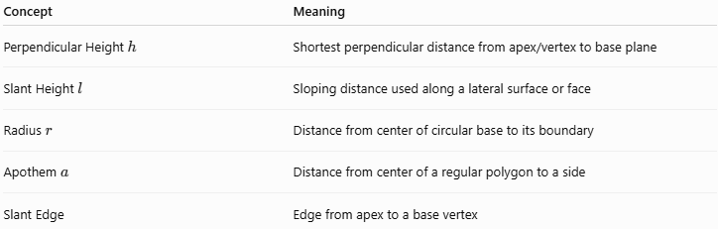
Concept | Meaning
Perpendicular Height $h$ | Shortest perpendicular distance from apex/vertex to base plane
Slant Height $l$ | Sloping distance used along a lateral surface or face
Radius $r$ | Distance from center of circular base to its boundary
Apothem $a$ | Distance from center of a regular polygon to a side
Slant Edge | Edge from apex to a base vertex
For a right circular cone:
$$\boxed{r^{2}+h^{2}=l^{2}}$$
For a regular pyramid:
$$\boxed{a^{2}+h^{2}=l^{2}}$$

Real-World Applications
# Source: AI Source: Provided by: [Data Path: Persons Table -> ID Column: 1, Name_En Column: Motasem Essam] -> From: [ChatGPT] on [7/20/2026]
Slant height is important in:
- Cone-shaped roofs.
- Tents.
- Funnels.
- Traffic cones.
- Conical tanks.
- Ice-cream cones.
- Pyramidal roofs.
- Pyramid structures.
- Sheet-metal fabrication.
- Packaging.
- Engineering and CAD.

Advantages
# Source: AI Source: Provided by: [Data Path: Persons Table -> ID Column: 1, Name_En Column: Motasem Essam] -> From: [ChatGPT] on [7/20/2026]
- Simplifies calculation of lateral surface area.
- Converts three-dimensional cone problems into right-triangle problems.
- Helps determine dimensions of conical and pyramidal surfaces.
- Essential for developing cone surfaces into flat patterns.
- Provides a direct connection between spatial geometry and the Pythagorean theorem.

Limitations
# Source: AI Source: Provided by: [Data Path: Persons Table -> ID Column: 1, Name_En Column: Motasem Essam] -> From: [ChatGPT] on [7/20/2026]
- The formula $l=\sqrt{r^{2}+h^{2}}$is specifically for a right circular cone.
- A general or oblique cone may have different generator lengths.
- Slant height and slant edge are not interchangeable for pyramids.
- The exact definition depends on the type of three-dimensional object.

Key Points
# Source: AI Source: Provided by: [Data Path: Persons Table -> ID Column: 1, Name_En Column: Motasem Essam] -> From: [ChatGPT] on [7/20/2026]
- Slant Height is a length measured along a sloping lateral surface or face.
- For a right circular cone:
$$\boxed{l=\sqrt{r^{2}+h^{2}}}$$
- For a regular pyramid:
$$\boxed{l=\sqrt{a^{2}+h^{2}}}$$
- Cone lateral surface area:
$$\boxed{A_{L}=πrl}$$
- Cone total surface area:
$$\boxed{A_{T}=πr\left(r+l\right)}$$
- Slant height is different from perpendicular height.
- Slant height is different from slant edge.
- The standard cone slant-height formula does not generally apply to oblique cones.

Conclusion
# Source: AI Source: Provided by: [Data Path: Persons Table -> ID Column: 1, Name_En Column: Motasem Essam] -> From: [ChatGPT] on [7/20/2026]
Slant Height is an important length measurement in three-dimensional geometry, particularly for right circular cones and regular pyramids. It represents the sloping distance along a lateral surface or face and is essential for calculating lateral and total surface areas.
For a right circular cone:
$$\boxed{l^{2}=r^{2}+h^{2}}$$
while for a regular pyramid:
$$\boxed{l^{2}=a^{2}+h^{2}}$$
Thus, slant height connects spatial geometry, surface measurement, and the Pythagorean theorem.

